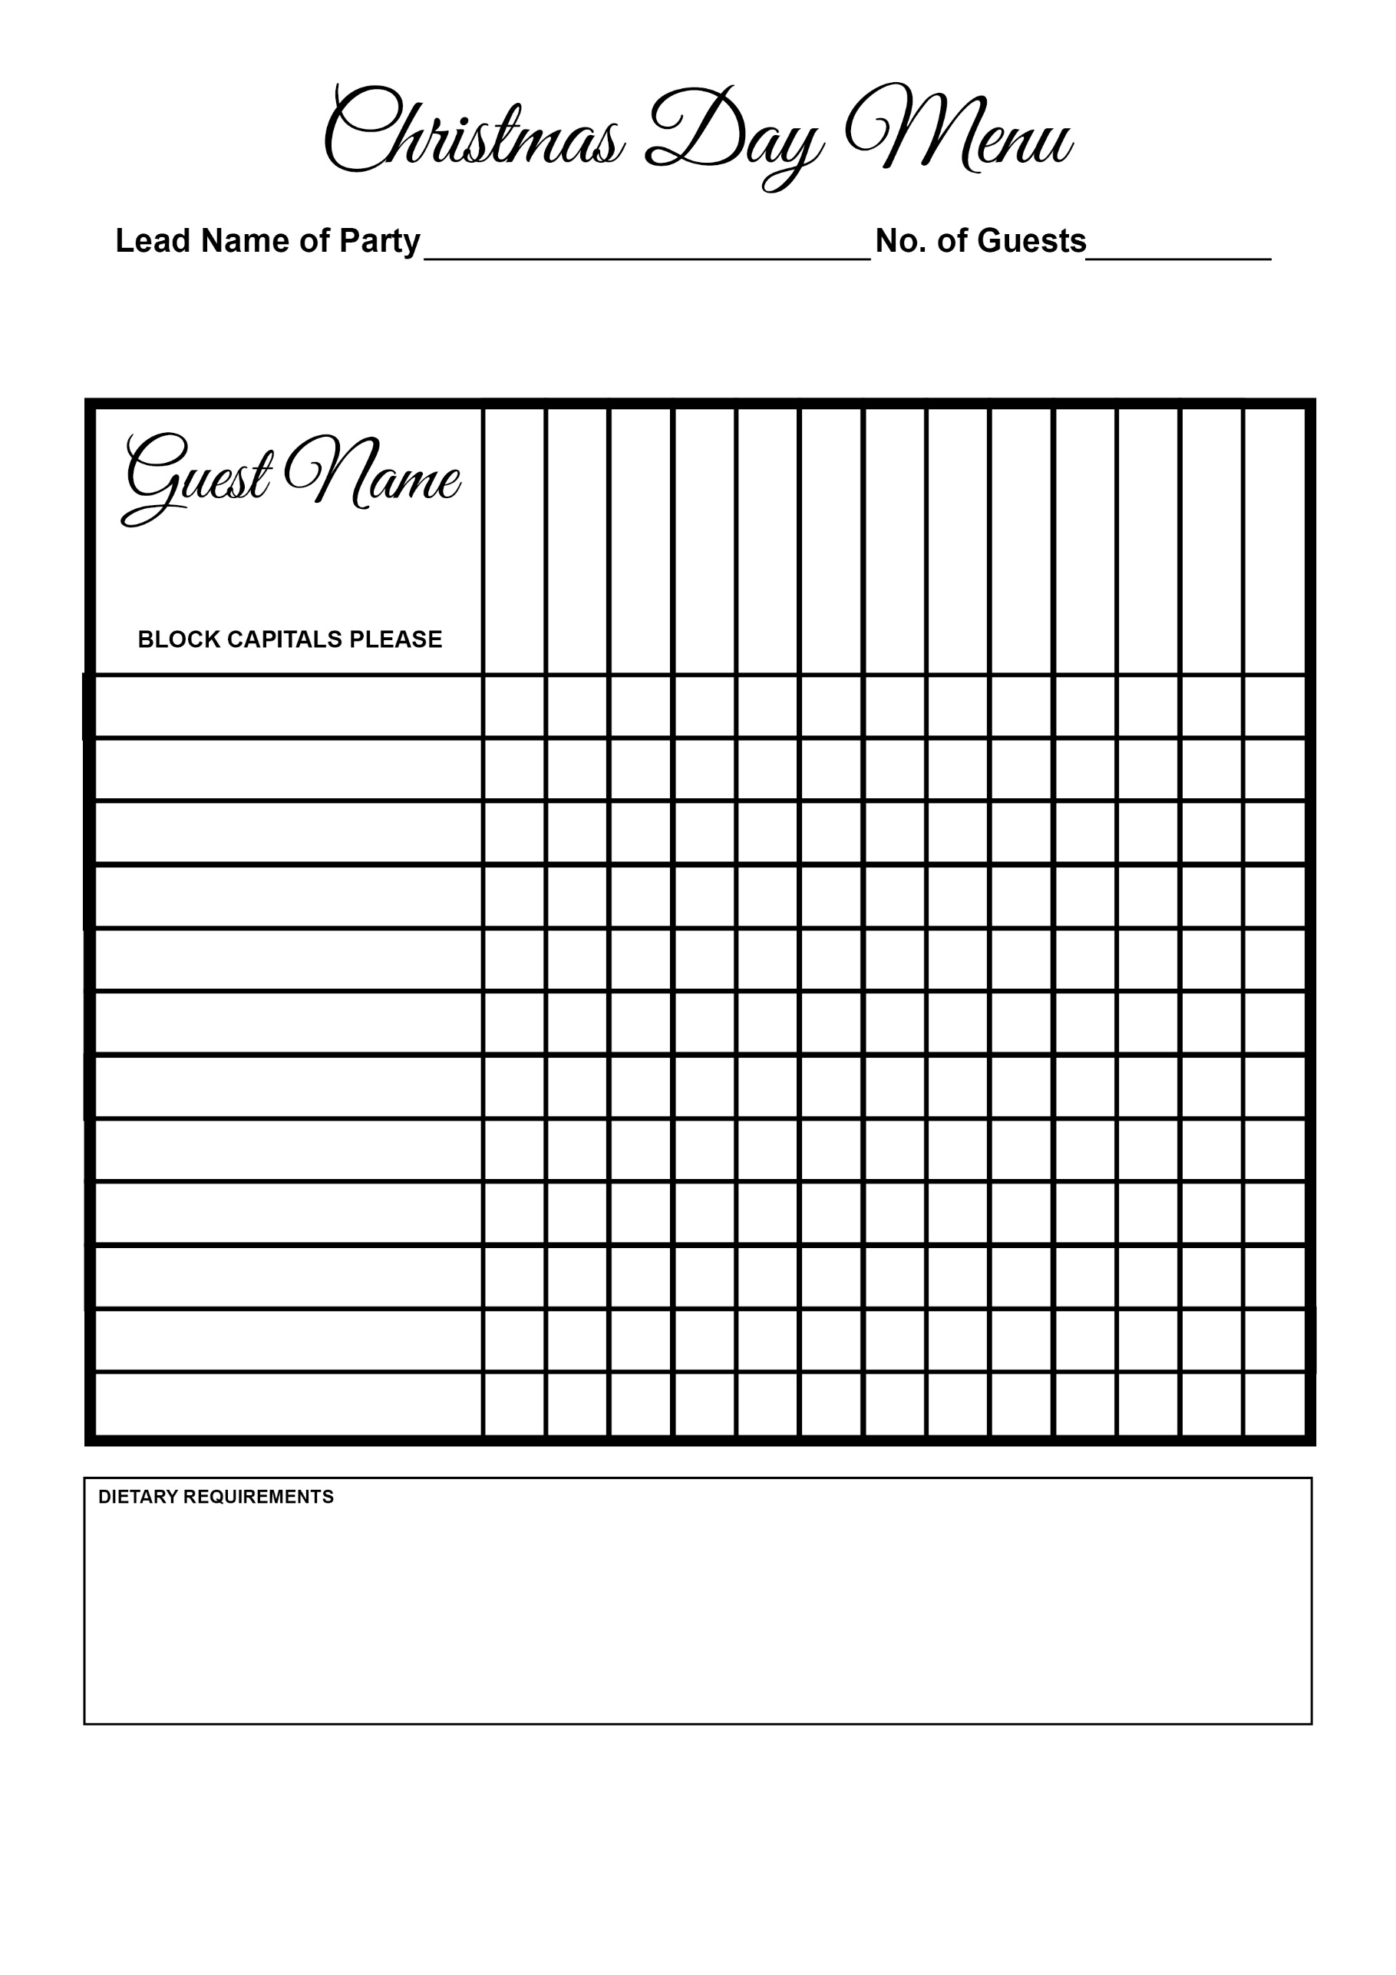

Selection of Cheeses

Christmas Pudding

Mousse

Sea Bass

Wellington

Turkey

Salmon

Duck

Soup